1. Introduction to Recursive Algorithms

1.1 The Concept of Recursion
Recursion is a computational problem-solving technique where a function calls itself to solve smaller instances of the same problem. A robust recursive algorithm requires two fundamental components:
- Base Case: The terminating condition that prevents infinite execution. In our financial model, the base case is reached when the algorithm requests a year for which we already have known historical data.
- Recursive Case: The logic that breaks down the current problem into a simpler sub-problem, advancing toward the base case.

1.2 Simplification of Complex Problems
Recursion allows developers to express complex, repetitive mathematical formulas natively in code. Instead of managing iterative loops and maintaining extensive state variables, recursion provides a declarative approach that mirrors the underlying financial formulas, resulting in cleaner and highly readable source code.

2. Algorithm Setup and Implementation
The financial forecasting module evaluates future values by calculating the growth rate between the two immediately preceding years. The formula is modeled as follows:
$$Value({Year}_{n}) = Value({Year }_{n-1}) * (1+ GrowthRate)$$
$$GrowthRate= \frac{Value\left({Year }_{n-1}\right)- Value({Year }_{n-2}) }{Value({Year }_{n-2}) }$$
In the accompanying Java implementation (FinancialForecast.java), this is handled by querying the previous two years recursively.
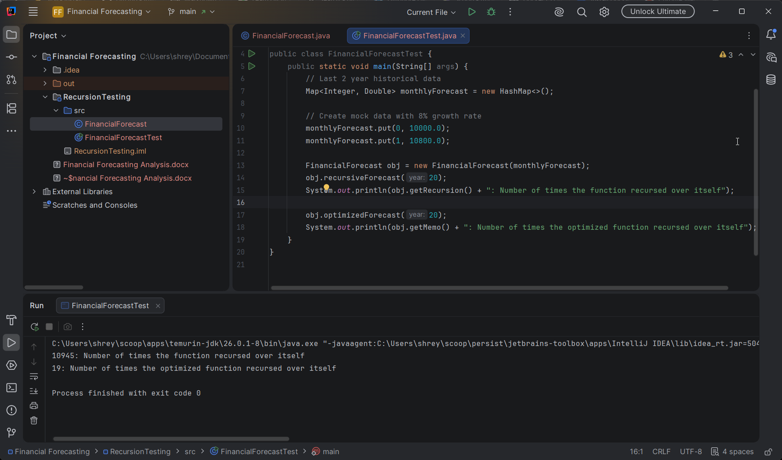

3. Time Complexity Analysis

3.1 The Naive Recursive Approach
The recursiveForecast method implements the mathematical formula directly without any state retention.
- Time Complexity: $O(2^{n})$ (Exponential Time) To calculate Year $n$, the algorithm must compute ${Year}_{n-1}$ and ${Year}_{n-2}$ . Consequently, to compute ${Year}_{n-1}$ it must compute ${Year}_{n-2}$ and ${Year}_{n-3}$ $.$This creates an overlapping execution tree where the same years are calculated repeatedly. As the forecast horizon ($n$)increases, the number of required computations doubles sequentially.
- Implication: This approach is computationally unviable for long-term forecasting. A 40-year forecast could lock the system thread for several minutes or trigger a Stack Overflow due to millions of redundant calculations.

4. Optimization Strategy: Memoization
To prevent the system degradation observed in the naive approach, we implemented an optimized solution using a technique known as Memoization (Top-Down Dynamic Programming).

4.1 Implementation Mechanics
The optimizedForecast method utilizes a Java HashMap to serve as a high-speed cache ("memo"). The execution flow is modified as follows:
- Cache Interception: Before performing any calculations, the algorithm checks the HashMap to see if the requested year has already been computed.
- Immediate Return: If the value exists, it is returned instantly in $O(1)$ time.
- Compute and Store: If the value does not exist, the recursive calculation proceeds, but the result is subsequently stored in the HashMap before it is returned to the caller.

4.2 Optimized Performance
- Time Complexity $O(n)$ (Linear Time) By caching results, we guarantee that the complex growth calculation for any specific year is executed exactly once. The execution time now scales proportionally with the number of years being forecasted.
- Space Complexity: $O(n)$ (Linear Space) The memory footprint scales linearly due to the storage requirements of the HashMap and the depth of the recursive call stack.

5. Conclusion
For the production deployment of the financial forecasting tool, the Optimized Memoization Approach is strictly required. While the naive implementation accurately reflects the mathematical theory, its$: O(2^{n})$time complexity creates severe performance bottlenecks. Utilizing a HashMap to cache overlapping sub-problems successfully reduces the computational overhead to $O(n)$, ensuring the platform remains responsive and scalable regardless of the requested forecast horizon.

